H2 Computing Summarised Notes

# Networking Fundamentals

## Part 1: Networks and Nodes

### 1.1 Network

A **network** is a group of devices that are **connected** together and can **communicate** and **share files and peripheral devices** (like printers) between each other.

### 1.2 Node

A **node** is a device or computer that is able to **connect to a network** and **generate, process and transfer data**.  
Each node has **addressing information** (MAC address) in order to allow other devices to communicate with it.

#### 1.2.1 Endpoint

An **endpoint** is a node that acts as a **source** or **destination** for data transfer.

#### 1.2.2 Redistribution Point

A **redistribution** point is a node that **transfers data** between other nodes.

(examples: network switches, router)

## Part 2: Local Area Network (LAN)

### What is a LAN?

A LAN is a computer network that covers a **small geographical area**.

(examples: home, office, school, a group of buildings)

### Characteristics of LAN

A LAN is usually…

* Based in **one** or **more than one** building
* The organisation operating the LAN controls its **speed**
* The organisation operating the LAN is responsible for its **management** and **maintenance**
* There is a **choice of technology**.
* There is **no outside involvement** from telecommunications providers, unlike many WANs.

### Network Configurations

A **network configuration** is a design specification for how the nodes of a network are **constructed** to **interact** and **communicate**, by determining the degree by which **communications and processing** are **centralised** and **distributed**.

#### Centralised Network

A **centralised network** consists of a **central mainframe computer**, which **handles all** the communications and data processing in behalf of clients.

These ‘clients’ connect to the mainframe computer via **dedicated terminals/terminal emulators**.

##### Advantages

* These central mainframe computers are **high performance**.
* It allows for management in the LAN to be **centralised**.

##### Disadvantage

* It is generally **very expensive to implement**, not optimal for smaller businesses.

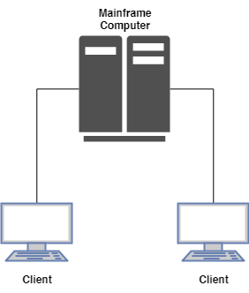

#### Client/Server Network

A client/server network is one in which **servers provide resources** to **clients**.

Usually, there is at least one server that provides **central authentication services**. Servers also provide access to **shared files, printers, hardware storage** and **applications**.

In client/server networks, processing power, management services, and administrative functions can be concentrated, while clients can still perform many basic end-user tasks on their own.

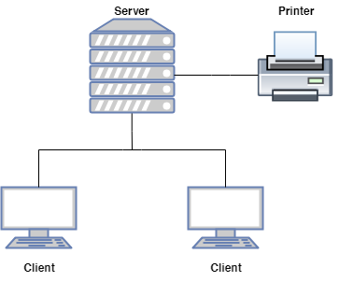

#### Peer-to-Peer Networks

A **peer-to-peer network** is a network in which resource sharing, processing, and communications control are **completely decentralised**. There are (at least) **two communication parties** with **equivalent roles and responsibilities** in apeer-to-peer network.

**Services and resources are distributed** on each computer for other computers to access. All clients on the network are equal in terms of providing and using resources, and each individual device authenticates its users.

##### Advantages

* **Easy** and **inexpensive** to implement

##### Disadvantages

* + Data storage and authentication is **not centralised**, hence it is **only practical in very small organisations.**
  + User accounts must be duplicated on every device from which a user accesses resources. This distribution of user information makes **maintaining a peer-to-peer network difficult**, especially **as the network grows**.

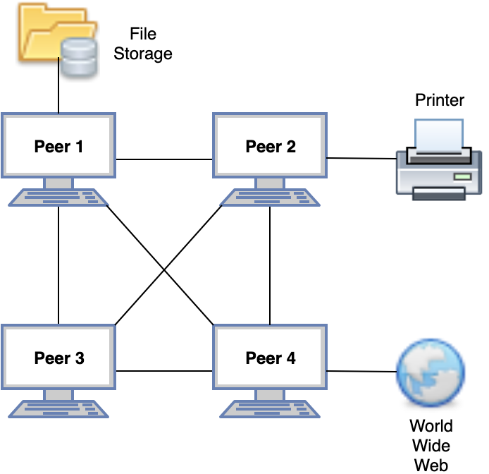

### Network Topologies?

**These are not required in the A level syllabus.  
Network topologies** are the physical shape of the network. There are three types: **bus**, **star**, and **ring topologies**.

### Types of Connections

#### Simplex Connections

A **simplex connection** is a connection that allows **communication in only one direction**, from the transmitter to the receiver.

#### Half-duplex Connections (HDX)

A **half-duplex connection** allows **communication to take place in both directions**, but only at **one direction at a time** (not simultaneously).

##### How half-duplex connections work

Typically, once a party begins receiving a signal, it must wait for the transmitter to stop transmitting before replying. Antennas are of trans-receiver type in these devices (transmitter and receiver) so as to transmit and receive the signal.

#### Full-duplex Connections (FDX)

A **full-duplex connection** allows **communication to take place in both directions simultaneously**.

##### How full-duplex connections work

These connections work by making simultaneous use of **two physical pairs of twisted cable**, where one pair is used for receiving packets (of data) and one pair is used for sending packets, to a directly connected device.

This effectively makes the cable a **collision-free** environment and **doubles the maximum data capacity** for a connection, as compared to a half-duplex connection.

#### Benefits of using full-duplex over half-duplex

##### Time is not wasted

**No frames need to be re-transmitted** using a full-duplex connection as compared to a half-duplex connection, as there are **no collisions**.

(In a half-duplex connection, if two or more stations/nodes transmit at the same time, signals will collide and become garbled.)

##### Full data capacity available in both directions

The **send and receive functions** in a full-duplex connection are **separated**, unlike a half-duplex connections where the same antennae send and receive data.

##### Nodes do not have to wait until others complete their transmission

This is because there is **only one transmitter** for each twisted pair in cables used in a full-duplex connection.

### Interconnection of LANs

LANs need to be interconnected for various reasons:

* **Structure an organisation’s network**:

Organisations are generally structured into divisions.  
Each one is likely to have its own LAN.  
To **enable communication** among the divisions, LANs need to be interconnected.

* **Extend maximum distance between stations/nodes**:

A division may be spread over several floors in a building.

Each floor is likely to have its own LAN.

Hence, there is a need to **interconnect these LANs.**

#### Ways to interconnect LANs

**Ethernet LANs:** Ethernet Hub  
Ethernet Switch  
Bridge

**Different types of LANs:** Bridge

#### Interconnection using Hub

It is a networking device used to **connect the nodes** in a physical **star topology** network into a **logical bus topology**.

A hub can be connected in a **multi-tier design** with a backbone hub at its top, hence allowing interconnection of entire LANs.

##### Advantage:

* If one hub is down, the remaining network **continues to operate**.

##### Disadvantages:

* **Only one station/node can transmit at a time** in the entire network, otherwise, there would be collisions. (i.e. lack of traffic isolation in the network)
* **Not too many stations** can be connected in the network.

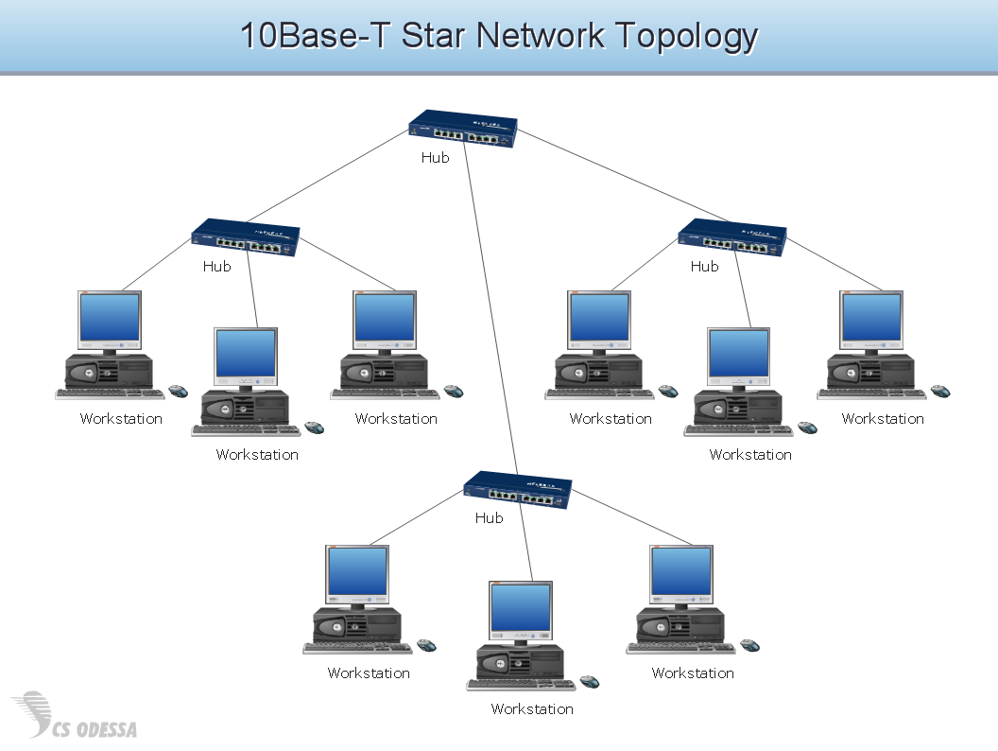

#### Interconnection using Switch

A switch is a network device that acts as a **common connecting point** for various nodes or segments. It breaks the network into **LAN segments**.

It **forwards messages** between the computers attached to it.

Switches **filter frames**, **isolating traffic** in the network. The frames on the same LAN segment are not usually forwarded onto other segments.

Like hubs, switches can be connected in a **multi-tier design** with a backbone switch as its top. This leads to further performance improvement.

##### Ethernet Switch

It contains two layers, the **physical** and **MAC layer**.  
It is capable of **buffering frames**.  
It examines **frame headers** and **selectively forwards** the **frame** based on the MAC destination address.  
Other links can be used to switch other frames simultaneously.  
Stations are unaware of the presence of the switch.

#### Interconnection using Bridge

A bridge has the **same basic functionality** of a **switch**, but it **has fewer ports** and is **software-based**.  
It **passes messages** between two segments of a (bus) LAN.

It can be used to segment a bus networks into two segments.

Bridge also has two layers, just like the switch.

### Network Architecture

#### Client/Server Architecture

##### Roles

**Client/Server**: The client and server are **two communications parties** with **different roles and responsibilities**. Services and resources are placed on the server for the client to access.

**Server**: It **hosts resources** (e.g. files) or **offers services** (e.g. Internet banking).

It is **always on** to wait for connections to come in. However, servers may be turned off during periods of maintenance/fault.

It is usually given **permanent addresses** so that it can be accessed easily.

**Client**: It **communicates with servers** to access services and/or resources.

A client usually **does not communicate with other clients directly**. However, this is possible via a server.

##### What is a client/server architecture?

There is at least **one serving computer (the server)** which provides all the **client** machines with all the facilities they need, which is usually file and printer sharing.

##### Disadvantages

* **Cost**

With client/server computing, there is a need to purchase a **central serving machine** that should be **fast** and have **huge storage capacity**.

* **Reliance on one central system** for provision of services

If this central system (the server) fails, **access** to all information and to the services on this machine **would likely be lost**.

#### Peer-to-Peer Architecture

In a **peer-to-peer architecture**:

* All nodes are **peer-to-peer**
* **No server** required
* A P2P node **may offer contents to others**. It makes this information available in the network.
* Other P2P nodes may access these contents **via direct communication**.

### Intranet

An **intranet** is a **private network** that uses **Internet protocols and services** to share an organisation’s information with its members/staff.

Just like the Internet, these members/staff can access an intranet via a **regular web browser** and **navigate an organisation’s web pages**. An intranet usually contains information that is segregated from the Internet due to **privacy** and **confidentiality** reasons.

Therefore, an **intranet** provides all the features of the World Wide Web, but **access is usually given to a closed group only, normally controlled by a password**.

#### Benefits of an Intranet

##### Over the Internet

* Access is **controlled**
* **More secure** than the Internet due to only authorised people having access
* **Faster** than the Internet as it usually covers a small area.
* **Less likely to crash** the websites due to less hits

##### Tangible Benefits

* **Inexpensive** to implement
* **Easy to use**, just point and click
* **Saves time and money**
* **Better information**, **faster** too
* Based on **open Internet standards**
* **Scalable** and **flexible**
* **Puts users in control** of their data

##### Intangible Benefits

* Improved **decision making**
* Improved **quality of life**
* Improved **productivity**
* Builds a **culture of sharing and collaboration**
* Facilitates **organisational learning**

### Enterprise Networks

It is a network that **includes elements of both LANs and** **WANs**. It is owned and operated by a single organisation